MRE 320 Sensors and Actuators Individual Project

Milestone #1: Get familiar with your sensor and propose testing plans

Name Hanqi Zhao

Fall 2022 MRE 320

**Introduction:**

**Color sensor :**Color sensor is also called color recognition sensor or color sensor. For the TCS3200, when a color filter is selected, it only allows a specific primary color to pass through, preventing other primary colors from passing through. The TCS3200 sensor has four types of filters: red, green, blue and clearT. The filter mode can be selected by the high and low levels of its pins S2 and S3, as shown in the following figure.

**Working principle of color sensor:** Color sensor is a form of "photoelectric sensor", which uses a transmitter to emit light and a receiver to sense the reflected light wavelength. Generally, color sensors can detect the combination of wavelengths belonging to the red, blue or green spectrum. The combined analysis of these three wavelengths gives the actual color of the object or light. The color sensor is used to generate an output signal with energy corresponding to the incident light energy, that is, it measures the wavelength of the received light.

**Procedure**

Part 1:

**Assignment:**

**(1)Wiring diagram of how you connect the sensor to Arduino, or a picture of your connected hardware**

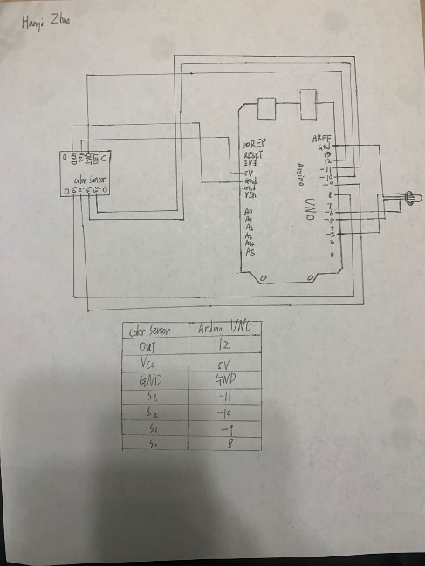

**(2)Arduino code**

/*********

  Rui Santos

  Complete project details at https://randomnerdtutorials.com

*********/

// TCS230 or TCS3200 pins wiring to Arduino

#define S0 4

#define S1 5

#define S2 6

#define S3 7

#define sensorOut 8

// Stores frequency read by the photodiodes

int redFrequency = 0;

int greenFrequency = 0;

int blueFrequency = 0;

void setup() {

  // Setting the outputs

  pinMode(S0, OUTPUT);

  pinMode(S1, OUTPUT);

  pinMode(S2, OUTPUT);

  pinMode(S3, OUTPUT);

  // Setting the sensorOut as an input

  pinMode(sensorOut, INPUT);

  // Setting frequency scaling to 20%

  digitalWrite(S0,HIGH);

  digitalWrite(S1,LOW);

   // Begins serial communication

  Serial.begin(9600);

}

void loop() {

  // Setting RED (R) filtered photodiodes to be read

  digitalWrite(S2,LOW);

  digitalWrite(S3,LOW);

  // Reading the output frequency

  redFrequency = pulseIn(sensorOut, LOW);

   // Printing the RED (R) value

  Serial.print("R = ");

  Serial.print(redFrequency);

  delay(100);

  // Setting GREEN (G) filtered photodiodes to be read

  digitalWrite(S2,HIGH);

  digitalWrite(S3,HIGH);

  // Reading the output frequency

  greenFrequency = pulseIn(sensorOut, LOW);

  // Printing the GREEN (G) value

  Serial.print(" G = ");

  Serial.print(greenFrequency);

  delay(100);

  // Setting BLUE (B) filtered photodiodes to be read

  digitalWrite(S2,LOW);

  digitalWrite(S3,HIGH);

  // Reading the output frequency

  blueFrequency = pulseIn(sensorOut, LOW);

  // Printing the BLUE (B) value

  Serial.print(" B = ");

  Serial.println(blueFrequency);

  delay(100);

}

**(3)Screenshot of the sensor reading**

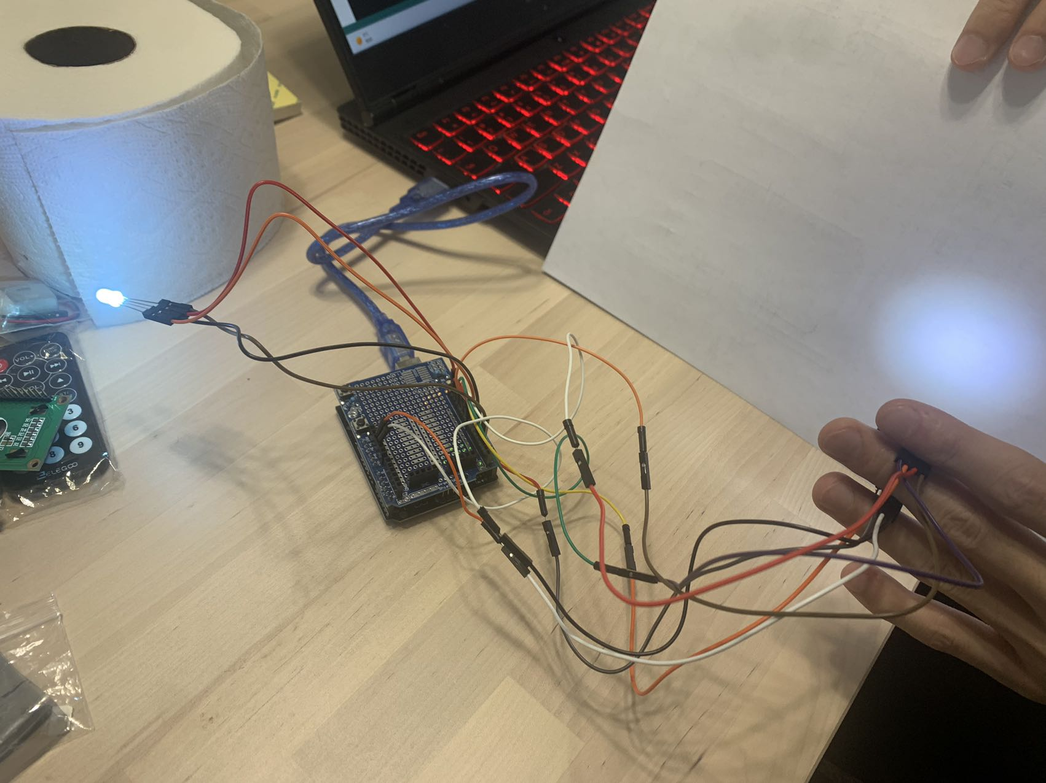

**(4)The summary of the main findings from your sensor study**

In terms of the color sensor, we need to know what the sensor does and how it measures. The first thing I saw was a color sensor with four bulbs on it. I thought these bulbs were going to do different color changes to show color measurements, but they're not, and it's also important for the connection of the circuit. I found that we need to find the RGB value of all the color we measured and then it connected to a new color.

Part 2

**Sensor parameter table：**

|  |  |
| --- | --- |
| **Specifications** | **Measurement** |
| Dimension | L*W*H 48*31*10 mm |
| Operating Temperature | 0~50 ℃ |
| Working Voltage | 5 V |
| Connector | 4 Pin |
| Signal Pattern | I2C communication |

Analysis of static characteristics

**measuring range:**

**Equipment:** iPad have a RGB app, a shoe box, UNO R3,TCS3200 color Sensor

**Methods:** First, put the iPad into the shoe box and adjust the RGB value. Then use the color sensor to illuminate the color on the iPad.

**Explanation of experimental procedures:** When the measured value is almost the same as the standard value, ensure that B and G remain unchanged. Change R, measure the range of R, and measure the range of B and G similarly.

**Summary:** According to the measurement, the range of R :

27-215, G:35-243B:5-92.

**Stability:**

**Equipment:** A ruler(0-30cm), one white paper,UNO R3, color Sensor

**Methods:** Fix the equipment and open it for a long time to observe whether the measured color is stable.

**Explanation of experimental procedures:** Through this method, we can know whether the color sensor can work normally for a long time.

**Summary:** After a long time of testing, we found that it has low stability and cannot work for a long time. If it works for a long time, the RGB is not right.

**Measuring Resolution:**

**Equipment:** iPad have a RGB app, a shoe box, UNO R3,TCS3200 color Sensor

**Methods:** First, put the iPad into the shoe box and adjust the RGB value. Then use the color sensor to illuminate the color on the iPad.

**Explanation of experimental procedures:** When the measured value is almost the same as the standard value, ensure that B and G remain unchanged. Change R, measure the change of R when the measured value change directly, that is the resolution, and measure the range of B and G similarly.

**Summary:** According to the measurement, the range of R :

49, G:32B:24.

**Error:**

**Equipment:** iPad have a RGB app, a shoe box, UNO R3,TCS3200 color Sensor

**Methods:** First, put the iPad into the shoe box and adjust the RGB value. Then use the color sensor to illuminate the color on the iPad.

**Explanation of experimental procedures:** When the measured value is almost the same as the standard value, ensure that B and G remain unchanged. Change R, measure the difference of R between the measured value and true value, that is error, and measure the range of B and G similarly.

**Summary:**

|  |  |  |  |
| --- | --- | --- | --- |
|  | **True value** | **Measured value** | **Error** |
| R1 | 142 | 153 | 7% |
| G1 | 159 | 180 | 13% |
| B1 | 43 | 50 | 16% |
| R2 | 109 | 124 | 13% |
| G2 | 129 | 143 | 10% |
| B2 | 30 | 40 | 33% |
| R3 | 153 | 143 | 10% |
| G3 | 166 | 160 | 3% |
| B3 | 58 | 49 | 15% |

We find that it has a big error and I think it is because of the four Led light has bright white light.